ECE-1000 Final Report: Self-Watering Plant System

Collin Davis, Kokou Edah

ECE1000

Cookeville, TN

[cmdavis47@tntech.edu](mailto:cmdavis47@tntech.edu), [kmedah42@tntech.edu](mailto:kmedah42@tntech.edu)

**Abstract**:Our Self-Watering plant system

Is designed to save time for the owner

of a plant. The owner will only periodically

need to fill up the reservoir that the pump

draws water from. The project is coded to

detect when the plants soil moisture

Percentage drops below a desired value

and when that value is less than the

desired value, a pump kicks on and

feeds water into the plant’s pot.

*Keywords: Plants, Water, RaspberryPi,*

*Soil, automation*

**Introduction***:* Our motivation behind designing

and building our project was to help save the life of our friend’s plant. Our friend Isaiah constantly neglected to water his plant so we designed a system to keep his plant watered. This project was worked on and built by Collin Davis and Kokou Edah, both being computer engineering majors. Both of us have a passion for automation and sustainability.

**Background:** Our Project was very code heavy. Using MicroPython we were able to read in information from a moisture sensor and also turn a pump on. A lot of our code was given to us by our TA, JC Williams. JC gave us the skeleton of the code and guided us in the right direction of filling it in. or circuit was done on the breadboard. Some of our connections required us to solder.

**Project Description:** Our project reads the soil moisture percentage and will pump water into the plants pot when below the desired percentage value. The wiring and soldering was done by hand. A single resistor was used to help prevent the motor from burning out.

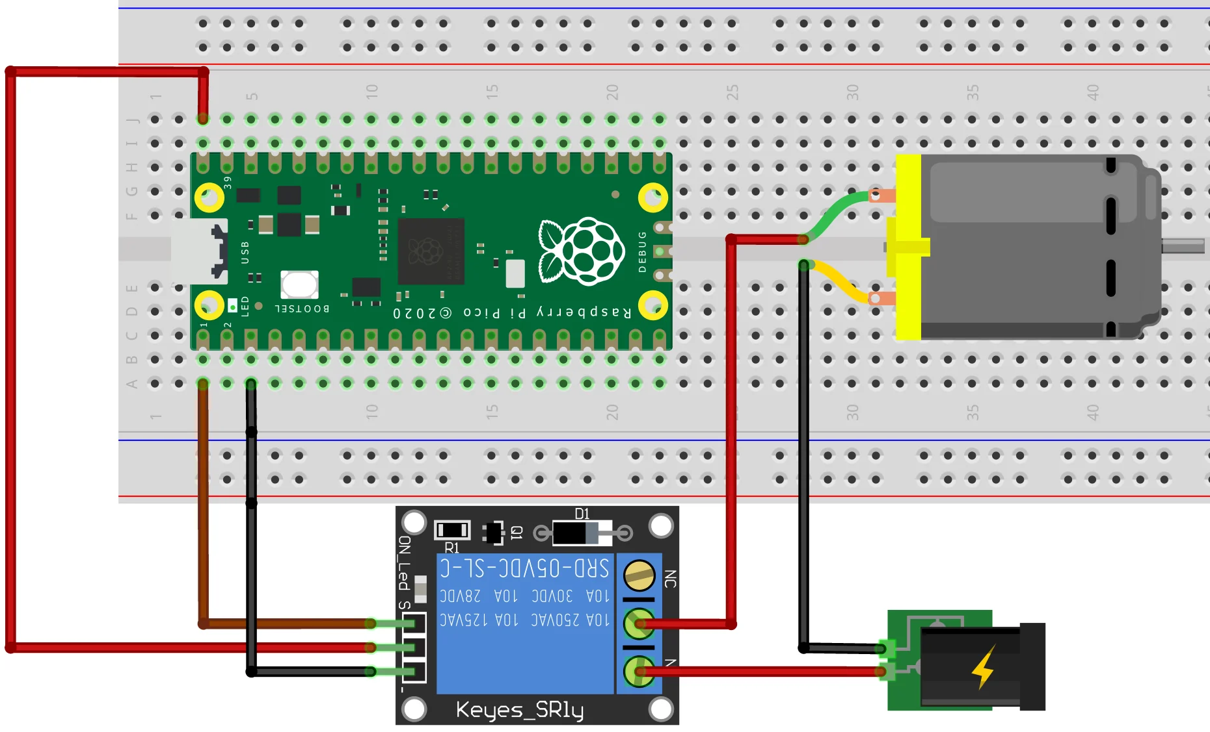

***RESULTS AND DISCUSSION***

Our Self Watering Plant was able to detect the low moisture in the soil and flow the water from the reservoir to water the plant. Once the moisture sensor detected that the soil was in the desired range for moisture, the water would stop flowing from the tube. We could have had better tubing for the water pump and reservoir because the water pump would fall over and the tube connecting it was held by duct tape.

***CONCLUSION***

In conclusion, our project was able to automate plant watering. While working on the project we were able to learn new skills like coding in Python and connecting wires to a Raspberry Pi Pico.